A Truly Clean Home is a Radon Free Home

How to Test
- Resolve to make your home’s indoor air healthy for your new child.
- Order a free radon test kit from your state radon office, or purchase a kit from a local home improvement store ($15).
- Follow the instructions in the kit. Usually you will test your house for 3 – 4 days, locating the charcoal test kit on a table one foot from a wall and away from open doors or windows on the lowest floor of the house that you live in.
- At the end of the test, put the kit in the self addressed post-paid envelope and drop it in the mail
- The lab will process the test and send you notice of the results
- If the radon test results are over the EPA Action Level of 4 pCi/L (picoCuries), the EPA recommends following up with a long term test.

Send for your FREE Test Kit
(California residents only)

Call the Radon Hot Line 800-745-7236
Or email gfaggell@dhs.ca.gov

Leave your name and address and a kit will be mailed to you.

Radon Information
for New Parents


Congratulations on the birth of your child! Now is the time to take an important step to insure that your child grows up in a
healthy environment.

TEST YOUR HOUSE FOR RADON.

Many homes in the Sierra Nevada have elevated levels of radon gas.

THE ONLY WAY TO KNOW IF YOUR HOME HAS HIGH RADON GAS LEVELS IS TO TEST!

Send for your FREE Test Kit Today!

Radon In The
Sierra Nevada

California
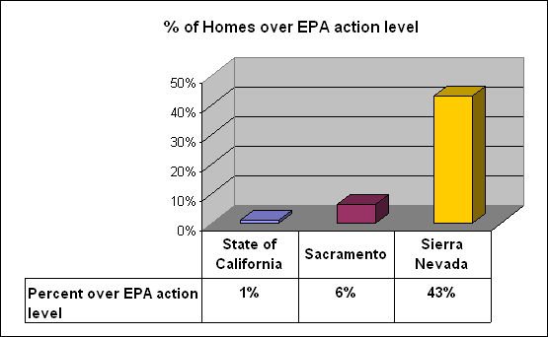

A recent survey of selected Sierra Nevada communities indicate that a high percentage of homes have elevated radon levels. This survey confirms a 1991 state radon survey that suggested that 50% of homes in the Sierras have high radon readings.
(See details at: http://www.radonattahoe.com/problem.htm)

The Lake Tahoe
Newborn Radon Program
is sponsored by:

California Department of Health Services Radon Program
http://www.dhs.ca.gov/radon

Radon at Tahoe
http://www.radonattahoe.com

Radon In The
Sierra Nevada

Nevada

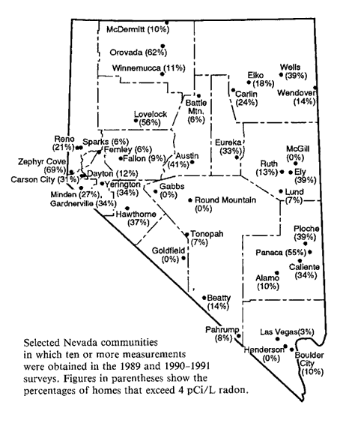

In a 1989 state-wide radon study, Zephyr Cove, on the shores of Lake Tahoe, held the dubious distinction of having the highest percent of homes with elevated radon readings in the entire state of Nevada, 69%!. This is another indication of the high radon levels in the Sierra Nevada.

1/13/2007 Radon at Tahoe

