2-12-13

This is a series emails and letters between myself and personnel in the California Department of Public Health Radon Program. The purpose was to find out why the radon program was not accomplishing more than it is. I started out asking what projects they are working on and then I asked for a budget. It took all of 2012 to get the budget request responded to.

Jeff

Correspondence with Willy Jenkins, Radon Program Scientist

2-16-12 Letter to find out what projects Willy is working on.

Subject: California radon programs

Hi Willy,
I am trying to find out what projects, if any, the California Radon Program is working on currently. Also, what is the makeup of the department? Are you assigned to the radon program full time? Looking to the future, how will California deal with the reduction in state funding from the EPA radon grant program that appears to be cut from the 2013 proposed Federal budget this morning?

2-17-12 Willy's response:

Hello Jeff:
Thanks for your patience. At this time the Radon Program continues to work on public outreach, responding to inquiries regarding radon and maintaining the Indoor Radon Program website. For the Radon Program I am the assigned staff person. If you would like to find out more about the Department I suggest you look at the information provided at the following link: http://www.cdph.ca.gov/programs/Pages/default.aspx . Regarding cuts or future plans because I am not the person making these decisions we will have to wait and see how the Department manages any potential reductions in funding.
Thanks for your interest.
Willy

Willy Jenkins
Environmental Scientist
Department of Public Health
Indoor Radon Program
1616 Capitol Avenue, 2nd Floor
MS 7404
P. O. Box 997377
Sacramento, CA 95899-7377
(916) 449-5674
Fax (916) 449-5665

Willy.Jenkins@cdph.ca.gov
http://cdph.ca.gov/Radon

10-22-12 Letter to Willy Jenkins

Hi Willy,
Sorry we missed you at the AARST and CRCPD Las Vegas Symposium. It is inspiring to meet and learn from the leaders in the radon education and action community. California was represented by (at least) myself, Jim Gorman, Fred Ellrott and his wife, Peter Mandel and Alfredo, and of course Dr. Ron Churchill of the California Geological Survey with his presentation on geological radon risk mappings of Tahoe, Ventura, LA, Santa Cruz and others. Ron's talk produced lots of interest and questions from the audience. Speaking of CRCPD, you should let them know your new information as they still list George Faggella as the California radon program director on their web site (http://www.crcpd.org/radon.asp#CALIFORNIA):
CALIFORNIA
George Faggella
Radiologic Health Branch
California Department of Health Services
P.O. Box 942742
Sacramento, CA 94234-7320
Phone: 916/449-5674
Fax: 916/449-5665
Toll free: 1-800/745-7236
E-mail: george.faggella@cdph.ca.gov
Website: www.dhs.ca.gov/radon/
After the conference I was re-energized to tackle some radon projects and I wanted to get your opinion of a few items:
1. What radon projects are you currently working on?
2. What are the California Radon Program goals for the coming 6 months to a year?
3. I have two ideas for projects I would like to work on and wonder if you have any suggestions or could offer support, encouragement or even leadership:
a. The California Association of Realtors has a Combined Hazards Book that lists radon as a natural hazard in California. Realtors in California are mandated to provide a Natural Hazards Disclosure report to buyers. This NHD report is produced by various Natural Hazard Disclosure Agents throughout the state, one of the larger ones being JCP-LGS Disclosures. These NHD agents currently disclose radon risks for each property address using the 20 year old EPA National Radon Map by counties. Ron Churchill's radon mapping project has uncovered hot spots within counties that are clearly a higher radon risk potential than the old EPA maps by total county show. South Lake Tahoe in El Dorado County is just one example of "high" and "very high" radon risks that are reported only as "moderate" radon risk in the California Natural Hazards Disclosure Report.
I would like to explore ways to get the mandated Natural Hazard Disclosure report to use more local and more recent radon maps, such as the ones the California Geological Survey developed, in place of the less accurate EPA National Radon maps, when local maps are available. There would have to some sort of agreement by all NHD agents to do this as agents who use the new maps might fear that real estate agents would take their NHD business to the agents that show the least amount of radon risk (whether true or not) and those less scrupulous agents would get more business if they used the older, less accurate EPA National Radon Map. Let me know what you think of this project.
b. The U.S. Green Building Council grants LEED awards for green building projects that meet a demanding list of requirements. These awards have become somewhat of an industry standard in the green building community, though they are not the only green building program around. LEED also use the old EPA National Radon Map to determine high radon risk areas where radon reduction systems are required in LEED building applications. I also would like to get the U.S.G.B.C. to use more recent and more local radon maps, where they are available. Many LEED awarded buildings in the South Lake Tahoe area in El Dorado County and the Tahoe City and Truckee areas of Placer and Nevada Counties have been built in known high radon risk areas with no radon reduction (RRNC) methods methods required because all three counties show "moderate" radon risk on the EPA map yet show high and very high risk on the local C.G.S. radon maps. Getting U.S.G.B.C. to agree to use more local radon maps where they are available is the goal of this project.
These two projects would allow the work of the C.G.S. radon mapping projects to produce real on the ground results in any county where radon maps are completed or in progress, in all future real estate transactions and in all future LEED green building projects. Let me know your views on these and any other projects you see as moving California forward regarding radon awareness and action.
There was also some talk about forming a coalition of radon professionals in California to work on common projects together. We will see if we can organize anything in that direction.
Thanks for your support and leadership in the fight to make more Californians aware of radon and to take action to reduce radon induced lung cancer deaths in California. (By the way, even though California is a relatively low radon state, our large population has produced estimates that we have the highest radon induced lung cancer deaths of any state, according to a chart shown at the Symposium by Phil Jalbert of the EPA. I need to get a copy of that chart!).
Jeff Miner
Radon At Tahoe
530-577-7293

No Response from Willy

10-25-12 Letter to Willy Jenkins

Hi Willy,
Have you had a chance to respond to my last email? If you are unable or reluctant to answer any of those questions, for whatever reason, could you please pass this email on to whoever is your superior in the chain of command in the Department of Health Services? As I recall, last time I inquired about "who's in charge" of the radon program, I was asked to fill out a Freedom of Information Act request. I certainly will do that if I am told to, but my purpose is just to have a conversation with the person responsible for the California Radon Program regarding my questions in the attached email. And please let me know if I should be directing this type of inquiry to some other source.
One more item, I noticed that the California Indoor Radon Levels Sorted By Zip Code data base has not been updated since 5/4/2010. Peter Mandel says that after George Faggella left no one has called to ask him to turn in his radon test results. Has the program of keeping track of test results by zip code been postponed or discontinued?
Thanks so much for keeping the California Radon Program alive in whatever capacity you can,
Jeff Miner
Radon At Tahoe
530-577-7293
http://www.RadonAtTahoe.com
11-1-12 Response from Willy's Supervisor, Mark Jeude:
Dear Mr. Miner:
I have been contacted by Willy Jenkins, Radon Program Staff Environmental Scientist regarding your communications concerning the CDPH Indoor Radon Program (Program). Hopefully my response will address your questions and concerns about the Program.
First, with regard to the zip code database, it’s our intent to keep this valuable database; however updating the database has been stalled due to the need to upgrade the computer programing in order to provide a more useful and compatible system.
In regard to the CRCPD members and program manager lists, CRCPD has been contacted by this Program to update the California information but changes have not been made. Hopefully CRCPD will update their lists in the near future.
In addition you had the following questions from an October 22, 2012 email.
1) What radon projects are you currently working on?
Program staff continues to conduct outreach, respond to inquiries, work with the service providers, maintain the website and databases and other tasks that occur on a daily basis within the Program.
2) What are the California Radon Program goals for the coming 6 months to a year?

Most importantly for the Program is to secure federal funding and enhance state support. As you are aware cuts in funding has placed restrictions on program activities. Also, due to travel restrictions for state employees, field activities have been limited.
Lastly, in regard to your projects, a) within this Program the process currently in place for California realtors, service providers and the general public to access radon information is working well and radon concerns are being addressed on a case by case basis; b) although the EPA California map has less detail, the Program believes it serves as a good starting point for all users. The next step for users would be to communicate with the state contact for more information. This Program continues to work with CGS to produce the more detailed localized maps and both CGS and CDPH departments post these maps on their websites.
Thank you for your comments, suggestions and concerns regarding the California Indoor Radon Program. However, due to limited resources, the Program needs to keep a focus on the areas that most benefit the people of the State of California. We appreciate your support of the Indoor Radon Program.
Mark L. Jeude, R.E.H.S., Chief
Environmental Health Services Section
Environmental Management Branch
1616 Capitol Ave., MS 7404
PO Box 997377
Sacramento, CA 95899-7377
(916) 449-5693
Fax (916) 449-5665
mark.jeude@cdph.ca.gov
12-1-12 Called Mark Jeude and requested a copy of the budget for the Radon Program

12-5-12 Response by Mark Jeude
Hello Mr. Miner,
I have received your request by phone for a copy of the California radon program budget. In addition our e-mail response from some time ago was met with more questions from you about the radon program. I do not know if I/we can answer all of the questions and fulfill all of the requests electronically. Our staffing levels do not provide for extensive searches and compilations of data. We also may not fully understand the nature of your requests and may be limited in the data that we can present to members of the public.
I would like to suggest that we meet in our Sacramento offices to discuss your concerns and issues with you in person. We may be able to provide information that you request at that meeting, determined by the nature and extent of your comments and concerns. I feel that by meeting in person with our staff and management, we could positively resolve your questions, issues, comments and concerns regarding the California indoor radon program.
Again, thank you for your interest in our indoor radon program, and look forward to meeting you in the future. Let me know if and when you can meet with us, and we will try to make the appropriate arrangements. I would suggest that if we do set up a meeting that we wait until after the holidays as many staff are planning to take time off.
Mark L. Jeude, R.E.H.S., Chief
12-5-12 My response to Mark Jeude still requesting a budget.
Hi Mark,
Thank you for the response. I would love to meet with you and discuss the radon program, but it's difficult for me to drive to your offices in Sacramento from my home in South Lake Tahoe, especially in the winter months. It would be easier and less time consuming for both of us if I could just get a copy of the operating budget for the radon program. I am interested in sources of money in and uses of money out, where the funds came from and how they were spent, or planned to be spent. That should not be too classified or require too much staff research as it probably is already a working document. Please let me know if that part of my request is possible and we will save our meeting to discuss the radon program for a later date.
Thanks for being open to discuss the program with me.
Jeff Miner
12-7-12 Phone call to Mark Jeude to again request a budget.
12-7-12 My letter to Mark Jeude after the phone call
Mark,
After our phone call today I guess I need to clarify why I have requested a budget of the radon program. The bottom line is that I do not think we are doing enough from a state level to address the radon issue in California and I would like to make a case that we do more. To do this I would like to start by understanding the state of the radon program now. To that end I requested a working budget of the radon program. I need the budget to show the details on money in, where funds come from, and money out, how the funds are spent, what programs, out reach, staff time, etc. Not pencils. Why this is so difficult to get is beyond me. Someone is making decisions within the Public Health Department on how to allocate funds to accomplish the Department's goals. Someone is choosing how much to spend and what projects to run in the radon program. It's my suspicion that it's not enough money and not enough projects in relation to the size of the radon problem in the State of California. But I don't really know until I can see the budget details.
Why this simple request has taken so long to be addressed and why it's got the department "all stirred up" is beyond me. Also why I have to wait 10 days for some federal law of Public Records information request, when I have been emailing and calling everyone in the chain of command above and including Willy Jenkins for this budget request for months, is also a mystery to me.
Is someone trying to protect their turf? Is the Public Health Department afraid of a little criticism or public scrutiny? Get real. You should treat requests for information on how you operate the same be it from critics or from supporters. You are a public agency and you should be pretty transparent on how you operate. Stonewalling someone for months over a simple request of a budget is pretty poor public relations whether from friend or foe. And believe me, I would love to be a friend and supporter of the radon program. I have a radon business in South Lake Tahoe and I have worked, in the past, with George Faggella, who ran the department before Willy Jenkins. We worked on projects together, we attended health fairs together, he spoke at events in South Lake Tahoe and helped me with my presentation at the Tahoe Environmental Research Center in Incline Village, NV. My feeling is that the radon program has not been looked at as a priority in the last few years. For example, according to the people at the EPA Region 9 in San Francisco, EPA SIRG grant monies require 40% matching funds from the states and California left some of that available grant money on the table by choosing not to come up with the all the matching funds for money available. That tells me someone in the line of command above the radon program decided that money was better spent elsewhere. Those are the kind of decisions within the DPH that I would like to address. But without a budget, I can't even start to build a case.
Maybe that's exactly what you do not want me to do, have the tools to be critical of the Department. Maybe I am having all this bureaucratic hassle because the DPH is somehow fearful of a little criticism by one person in South Lake Tahoe. My goal is a better radon program. Whether you agree with that or not, you should at least respond to my request for information and allow me to state my case.
Jeff Miner
12-5-12 Note: By this time I am obviously frustrated in not being able to receive something so simple as a working budget for the radon department, I proceeded to call everyone in the line of command up from Willy Jenkins to Mark Jeude, to Kelvin Yamada, Mark's Supervisor. When I was unable to get a response from anyone, I went to the top and sent a letter to the Director of the Department of Public Health, Ron Chapman, to complain about the frustrating process of obtaining a radon budget.
12-7-12 My letter to Ron Chapman, head of the DPH
December 7, 2012

Jeff Miner
Radon At Tahoe
PO Box 2576
South Lake Tahoe, CA 96158

htp://www.RadonAtTahoe.com
530-577-7293

Ron Chapman, M.D.
Director of Public Health
California Department of Public Health
PO Box 997377
MS - 0500
Sacramento, CA 95899-7377

Dear Dr. Chapman,

I would like to issue a complaint against the managers in the Environmental Management Branch on how they have handled a request for information. I have asked for an operating budget for the Radon Program, which is under Environmental Health Services in that Branch. After over 2 months and multiple phone calls and emails, I still do not have a copy of that Radon Program Budget. It seems I am being stonewalled for requesting what should be public knowledge: how the Department of Health spends its money.

Here's the chronology of the requests:

Feb 13, 2012, Feb 16, 2012 Oct 22, 2012 Oct 25, 2012 Communicated with Willy Jenkins, Radon Program, about the state of the program. When Willy told me that funding and decisions on which projects to pursue, were not his call I asked him to pass my requests on to someone up the chain of command who makes those decisions.
Nov. 1, 2012 Mark Jeude, Chief, Environmental Health Services Section, responded to my letter to Willy.
Nov 6, 2012 I asked Mark Jeude for a budget of the radon program to better understand how money was obtained and how it was spent.
Dec 5, 2012 After not receiving any response for a month, I made phone calls to everyone I could find in the line of command above the Radon Program (Mark Jeude, Kelvin Yamada, Mark Starr, I spoke with Kathleen, Mark Starr's secretary) asking how I could obtain a copy of the Radon Program budget. Mark Jeude sent me an email suggesting we meet in his office in Sacramento.
I emailed back that it is difficult for me to travel from my home in South Lake Tahoe to Sacramento, but that a copy of the budget should not require a meeting.
Dec. 7, 2012 I called and spoke to Mark Jeude. He agreed to get me a non-detailed copy of the Federal requested budget but it would have to go through the Public Records Information Request that would require 10 days from yesterday, Dec. 6th. I said I requested it over a month ago, actually on Nov. 6. Also, a non-detailed budget is not what I am looking for. I need a working budget that shows money in and money out, where it comes from and how it gets spent.
Dec 7, 2012 I wrote Mr. Jeude the attached email which states my frustration at not being able to request and receive something as simple as a budget of one of the programs in the Department of Public Health.

I am frustrated in having to spend so much time with what should be a one phone call request. My complaint is that the DPH makes the public go through so much bureaucracy to get some information about how the Department spends public money. The chance of my ever getting a copy of the working budget of the Radon Program is still remote and the process should certainly not have to be so tedious.

Jeff Miner
12-7-12 Mark Jeude finally responds from the telephone call with a copy of the EPA grant request dated 7-29-11. This document actually gives some good data on what was requested from the Federal Government, and the matching funds from the State, and how the money is proposed to be spent. This was the first good data I obtained from this process. However, it did not show the internal budget for the department or how the money was actually spent.
Mr. Miner,
Enclosed are the documents that the department has in response to your request. The method for funding is contained in the Department of Finance and the budget act, and consists of broad categories such as whole divisions. Because the Radon program applies for grant money from federal sources, more detail is available than other programs.
Mark L. Jeude
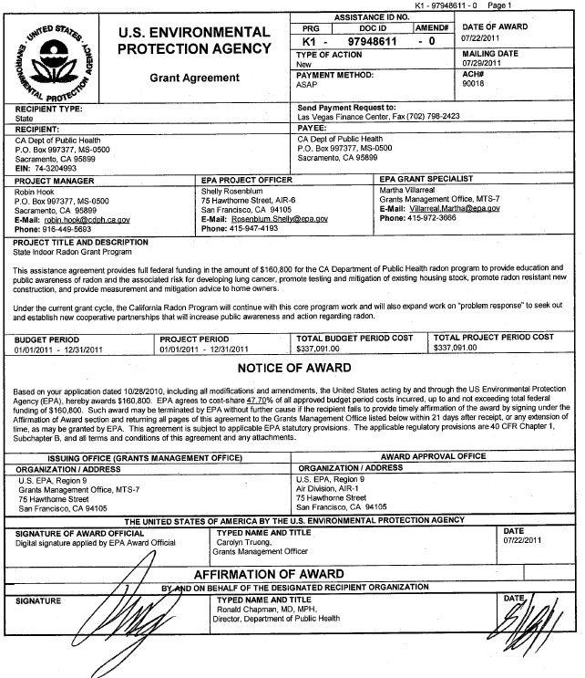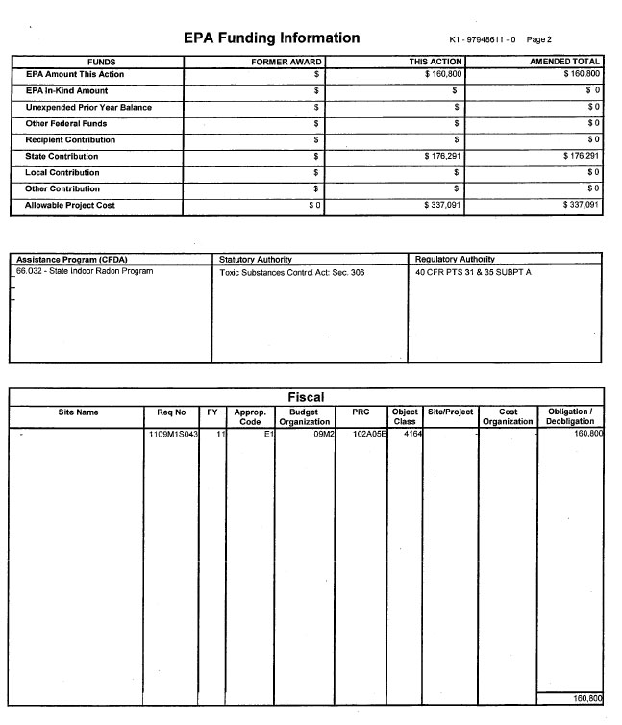
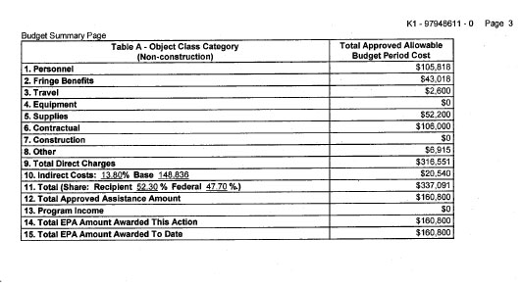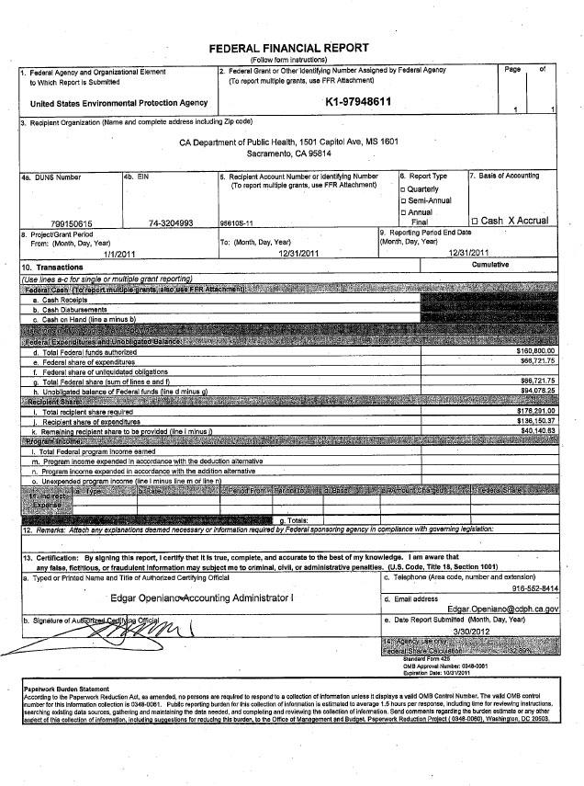

12-28-12 Response to my letter to Ron Chapman from Leah Walker for Ron Chapman
Note: This response really missed the point of my letter. First it missed the part about the complaint of being given the run-around by middle management and then it missed the point about wanting a detailed budget. She provided me with a very summarized three line budget.
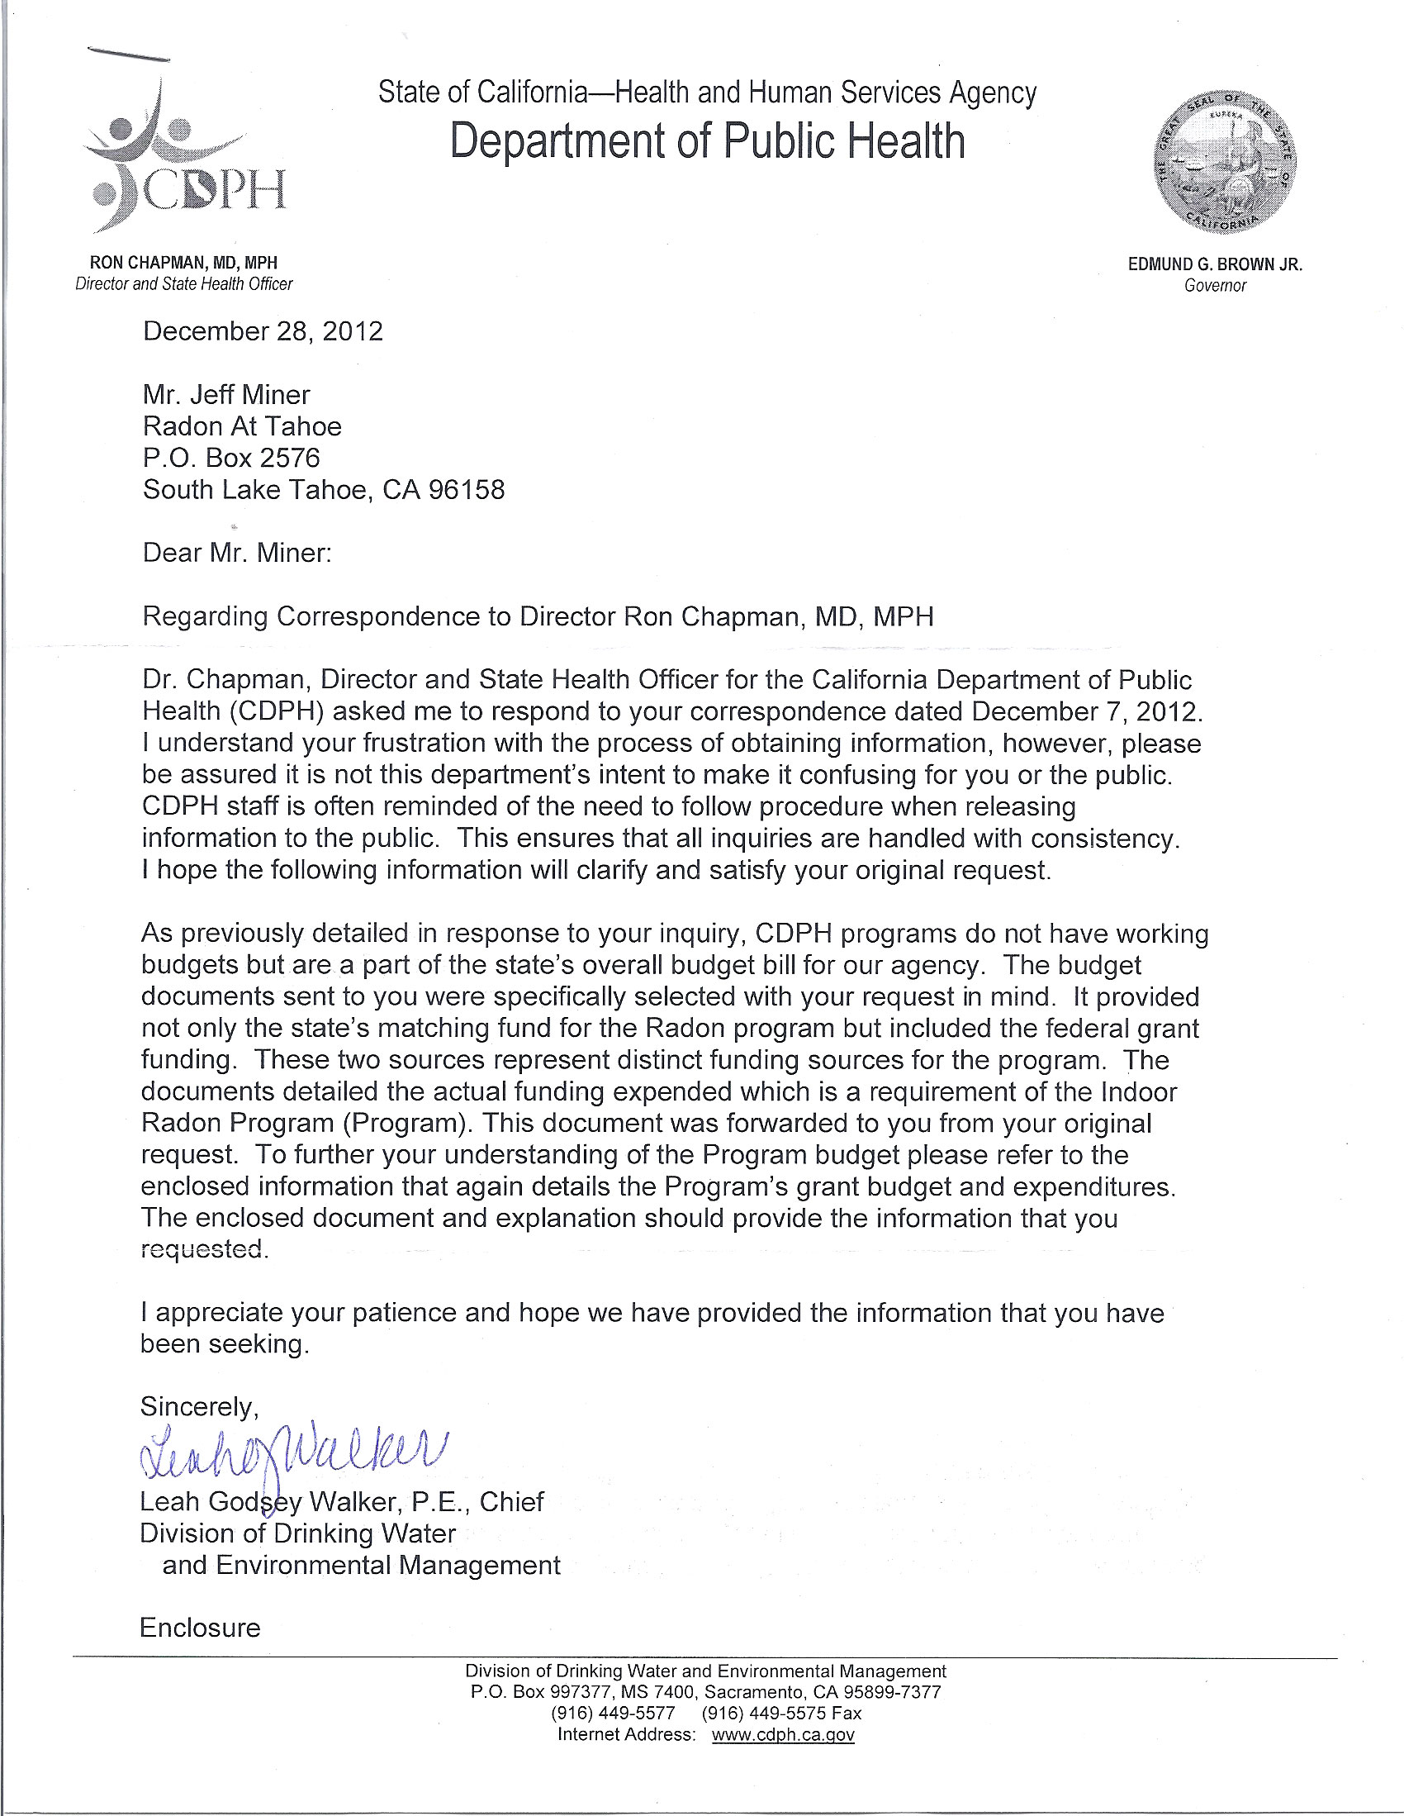

Attached to that letter was the following 3 line-item budget summary:
Environmental Management Grant
State Indoor Radon
Budget = $129,000
Projected expenditures = $111,550
Net fund balance = $17,450
Note: These figures do not match the EPA SIRG Grant data, so I do not know what they refer to. But I figure this is all I am going to get from my budget request. Next I will look at how they spend that money and what results they are getting.
1-2-13 Previously, for comparison of funding and accomplishments, I had requested the working budget data from the Nevada Radon Education Program, run by the University of Nevada Cooperative Extension and supervised by Adrian Howe of the Nevada Radiation Control Program. This is a model state radon program with lots of educational outreach, radon talks at public libraries all over the state, free test kit distribution, a quarterly newsletter, school radon poster contests, etc. Very high profile and surprisingly with the same budget as the anemic California Radon Program. Also, when I requested the budget data I received 23 pages of detailed budgetary figures for 2012.
Budget Summary:
Total Indoor Radon Program = $358,334 (nearly the same as $337,091 for California)
SIRG Grant Funds = $215,000
Non-Federal Matching Funds = $143,334
2-11-13 I had been in contact with several people in the California Office of the Budget but they were too busy with getting out the Governor's budget in January. I contacted them again in February and was told to go through my State Representatives if I wanted a budget audit of the Radon Program. I contacted State Senator Ted Gaines and was told to send a draft letter that Senator Gaines could use in contacting the DPH. It should be modified, but it states my concerns. Mat Cox is a political aid to Senator Gaines.
Hi Matt,
Chandra Brown suggested I contact you about a problem I am having with the management of the California Radon Program under Environmental Sciences in the Calif. Dept. of Public Health. I run a radon consulting business in South Lake Tahoe and I am certified as a radon mitigator with the Calif Radon Program. The program has deteriorated in the last couple of years and I am concerned that it is being mismanaged and that funds, both state and federal, are not finding their way into radon awareness programs that they are intended for. In voicing my concerns to the DPH, I have been stonewalled, denied access to basic budget data and treated like a bother they would just as soon bother someone else. However, I am a customer of that radon program and I need the services they have either reduced or never pursued to begin with. Also, Federal and matching State monies fund that program and they should be providing the people of California with the radon awareness programs we are paying for. Thus, I have not stopped in my efforts to get the DPH to be accountable for the money they are spending and the results (or lack thereof) they are producing.
Chandra Brown suggested I write a draft letter for Senator Gaines to send to the DPH, which is attached. It is really a draft and only showcases a few of the complaints I have, but it is a start. Hopefully, if you are interested, I could go into more detail, or maybe you can reduce it to more of a summary, but I will leave that up to you. I have attached the draft letter and if you are interested, I can send via mail the 1 page response I got from CDPH and the corresponding 23 page response I got from their counterpart in Nevada, much more transparent about what they do and how much it costs than in California. It's quite a contrast. You can also see the differences in their web pages below. Same funding for both state programs, by the way. Somebody should be ashamed.
Some resources:
My web page at Tahoe: http://www.RadonAtTahoe.com
California DPH Radon Program: http://www.cdph.ca.gov/HealthInfo/environhealth/Pages/Radon.aspx
Nevada Radon Program: http://www.unce.unr.edu/programs/sites/radon/
Thank you for considering my plight,
Jeff Miner
Radon At Tahoe
P.S. If this is not the kind of thing you get involved in, please let me know where else I can go to effect change in that poorly managed program.
I attached this Draft Letter for Senator Gaines to use or revise.
Date 2-11-13
To: Matt Cox
From: Jeff Miner
Subject: Draft letter on CDPH Radon Program

Chandra Brown suggested I put together a draft letter for Senator Ted Gaines regarding my complaints about how the California DPH Radon Program has been run. This is only a draft. Let me know if you need any additional data. I have plenty more.

Jeff Miner

Proposed draft letter from Senator Ted Gaines to the California Department of Public Health, Radon Program

CDPH, Radon Program,

It has come to my attention from one of my constituents in El Dorado County that the Radon Program has been functioning at a minimum level for the last few years. We are looking for some explanation as to this decrease in productivity and looking for proposals to increase that productivity in the future. Here are some stated evidence of that loss of productivity:

1. Radon Database: The Radon Test Data Base by zip code has not been updated since April of 2010. This data base is used by radon professionals and by the general public to see which zip codes in California have a high percentage of homes with elevated radon levels. This data base is also a prime basis for the California Geological Survey Radon Maps that have been published in the last few years. The explanation given my constituent was that the data base had to be "converted" and there was no money to do that. Could it just be converted to an Excel Spreadsheet which would require less programming and at far less cost?

2. Radon Program Budget: My constituent stated that he asked for an operating budget for the Radon Program and was told that no operating budget existed. We would like to know how much money is funneled into the radon program, and from what sources, and how those funds are spent. We would like details to see how those U.S. EPA SIRG (State Indoor Radon Grant) Funds are budgeted to be spent and how they are actually spent. Because of the decline in radon services provided by the Radon Program in the last few years we are concerned that those funds earmarked for the Radon Program may have been spent on other, though possibly useful, programs but other than the radon programs for which they were intended (and required by law). One response my constituent received from his budget inquires was from Mr. Mark Jeude, which was the EPA SIRG Grant application for 7/22/2011 showing the source of the money: EPA amount = $160,800 and State Contribution = $176,291, Total = $337,091 with the EPA budget for the use of the money (see attached). The other response was from Ms. Leah Walker which only showed 3 figures: Budget = $129,000, Projected Expenditures = $111,550, Net Fund Balance: $17,450. Can you provide us with greater detail on how the funds were actually used?

3. Radon Program Accomplishments: The proof is usually in the pudding. What was that $337,091 able to accomplish? Well, you did contract with an outside radon lab to provide radon charcoal test kits to California residents for $7.95 each. And you did maintain the Radon Certification Program for 9 certified radon mitigators and for 65 certified radon testers. But as far a outreach programs you did not publish a quarterly newsletter, or arrange for talks at local public libraries, or support a staff around the state, or develop a radon poster contest in the schools, or go to green building conferences as past radon managers have done, or even ask the Governor to proclaim January as National Radon Action Month, as he has done in previous years. As a benchmark, we could compare the effectiveness of the California Radon Program to the Nevada Radon Program. They both had similar funding: California = $337,091, Nevada = $358,334. But Nevada has a robust radon awareness program for the same money spent with staff, public outreach, free test kits, library programs throughout the state, quarterly newsletters with statistics on improved outreach, etc, etc. Have the people of California been getting their money's worth? We should be managing our radon program better, with an eye on outreach and public accountability.

Other Considerations:

1. Staff Turnover: It could just be a coincidence rather than an indication of poor management (or a poor employee selection process), but George Faggella, after many years as the Radon Program manager left in 2011 and Willy Jenkens who took over for George is leaving now.

2. Transparency: I am sending in a separate envelope the 23 page budget response I received from the Nevada Radiation Control Program radiation physicist, Adrian Howe, along with some of the quaterly radon newsletters that show the effectiveness of a well run radon program. Compare this to the three line response I received from the California Department of Health when I asked for details on the radon program budget.

I hope this information can be a start in figuring out how to demand more from our government institutions when it comes to them being accountable for the money we pour into their budgets and for the expectations we have for them doing their jobs. Radon accounts for more than 21,000 deaths a year in the U.S. and California has the highest radon induced deaths of any state. Radon is the leading cause of lung cancer deaths after cigarette smoke. The new California Radon Map studies from the California Geological Survey are about to increase Californian's awareness of where radon hot spots are in the Golden State. The Department of Public Health Radon Program has an important role to play in those awareness programs and I hope we can encourage them to step up to the plate and do a better job.

Jeff Miner
Radon At Tahoe

2-12-13 Note: So at this point I have to decide where to take this. I have to assume that the California Radon Program management is not doing its job either due to corruption or incompetency. Either management is assigning the radon program manager to other assignments, using federal and state radon funds, which would be illegal, or they are just not managing his time well to get anything useful done. Especially when you compare the California radon program to the one in Nevada with nearly equal funding but with huge discrepancies in results.

Here are some options going forward:

1. Call for a budget audit from the Office of the Budget. This would have to be requested by my elected representatives: State Senator Ted Gaines, and State Representative Frank Bigalow.
2. Contact the State Grand Jury and request a Grand Jury Investigation of the Radon Program.
3. Contact the University of California Cooperative Extension and ask if they would be interested in taking on the radon program, similar to how it is organized in Nevada.
4. Do nothing.

